Mars Enterprise Bugs/Changes Document

- Resolve this Type of error user cannot identify the error (Which required field?)
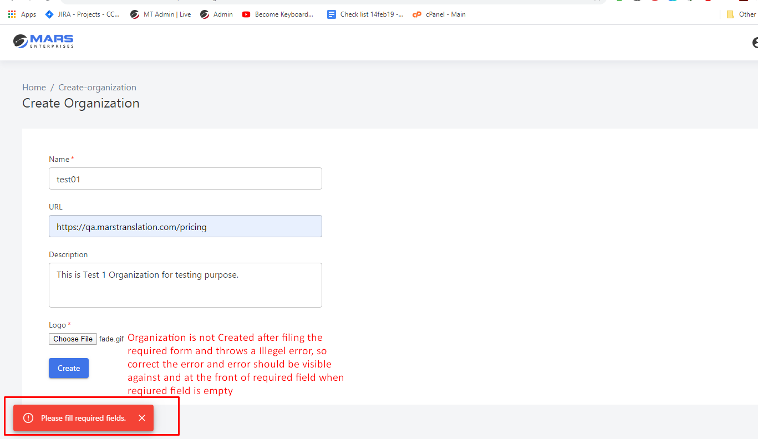
- Add validation on upload Logo Image (just .JPG and .PNG Allowed)
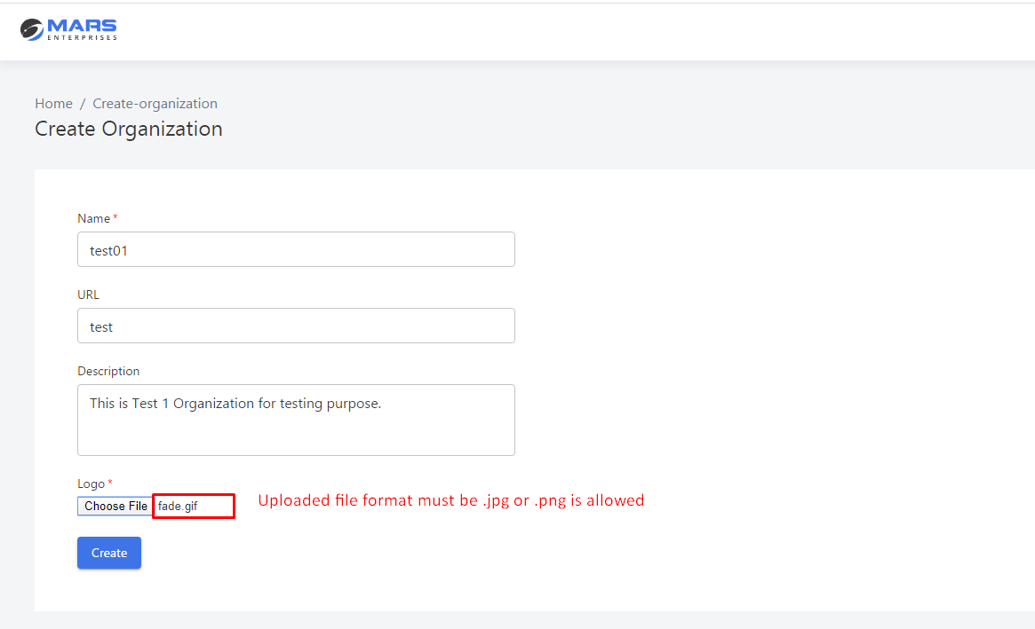

- See the changes or problems in given picture
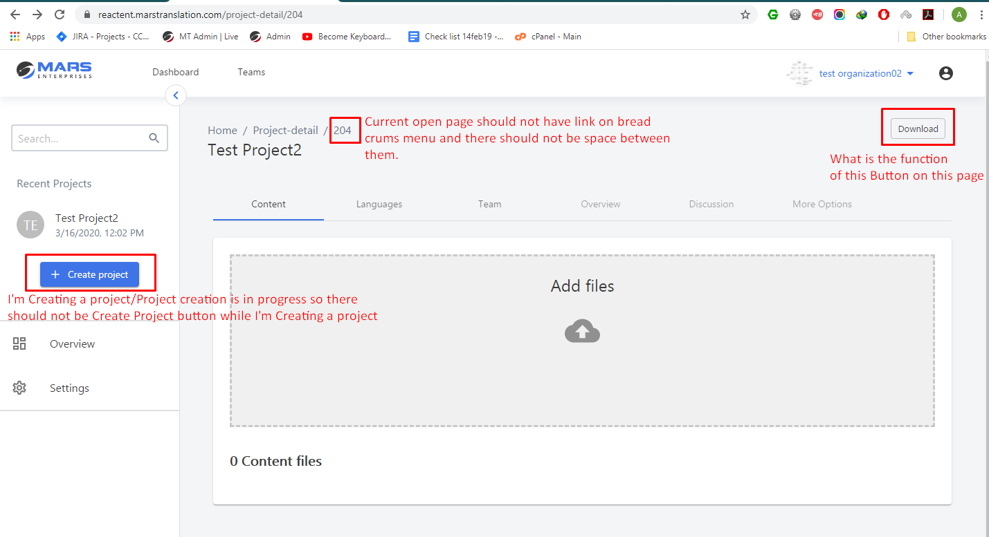
- Design is not correct as given by Anees.
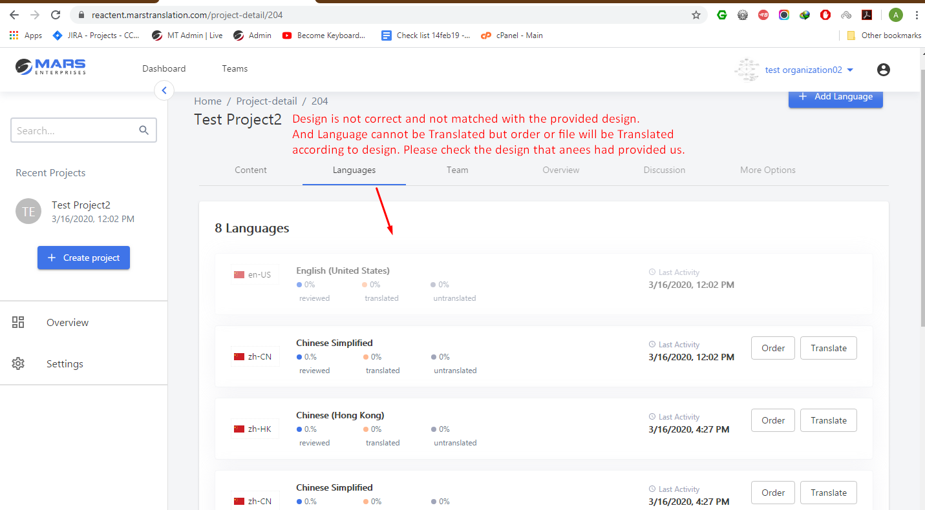

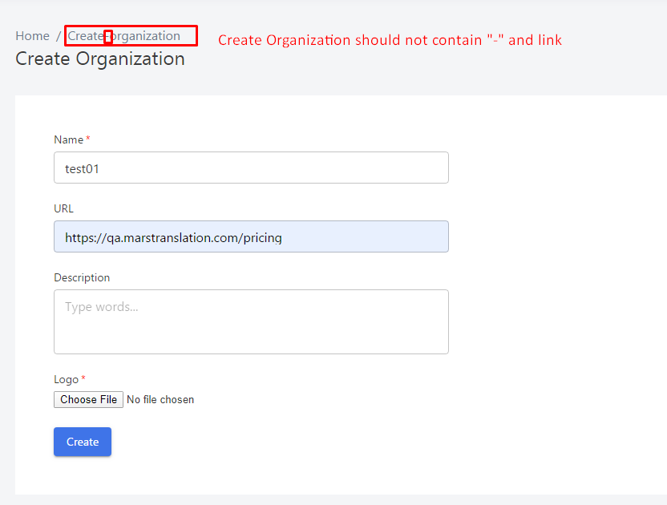
- There should be confirmation Popup When Unlink the Realtime
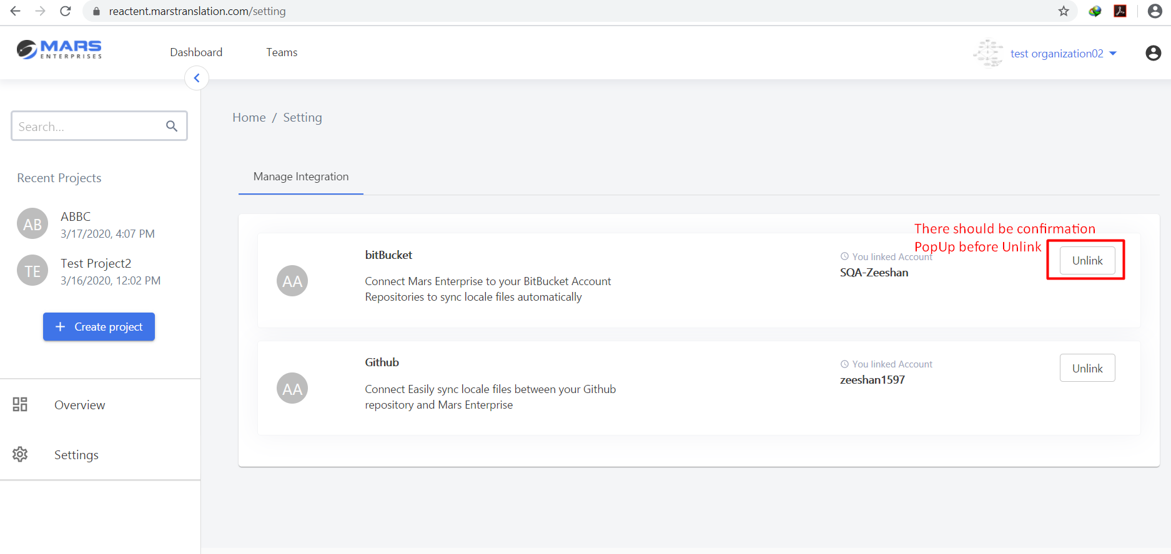

- Add the Validation of file extension as Sir Mudasir has mentioned in the group.
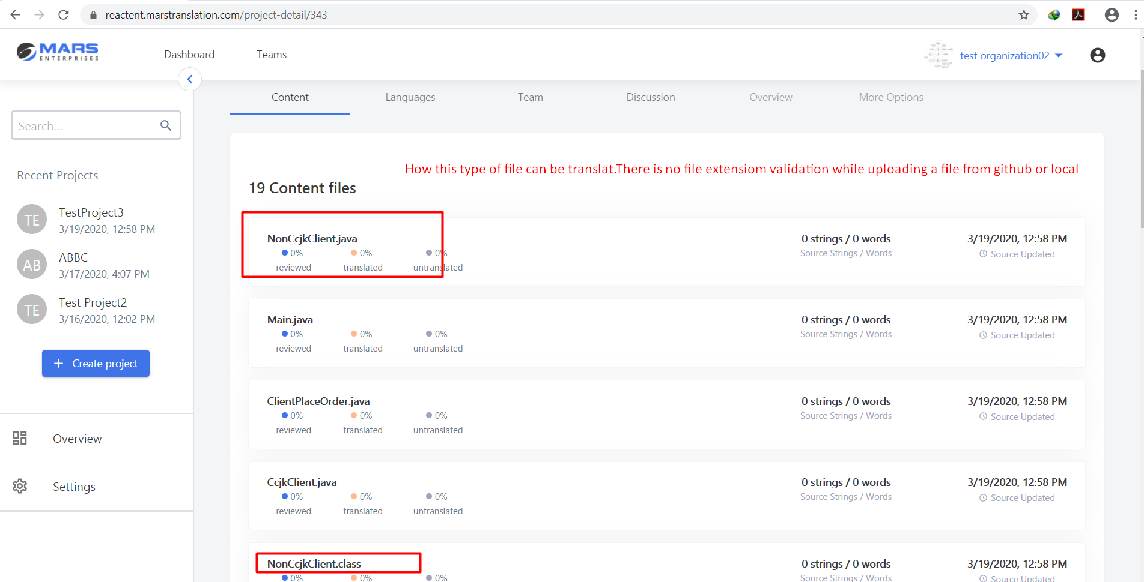
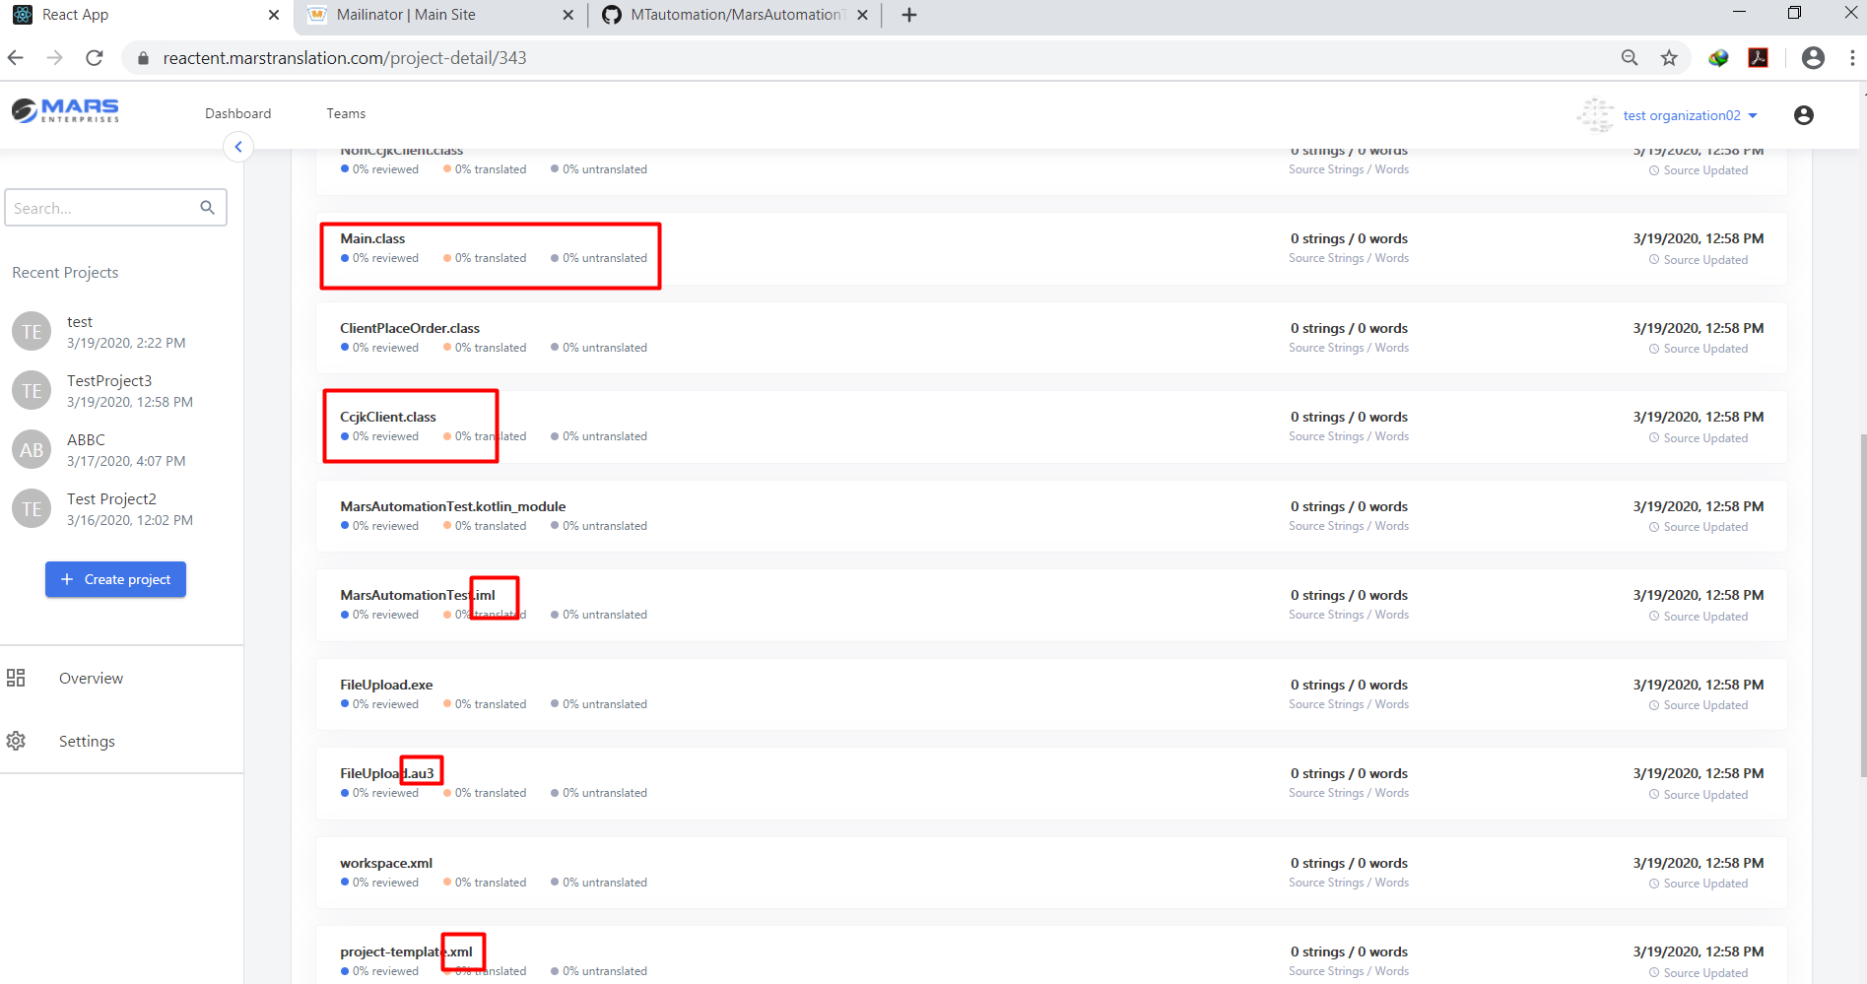

- The Languages are adding duplicate so Add the validation (already added language cannot be add again)
